## Upcoming Events

* 9/1 SAC Meeting @ 3:15
* 9/3 K APTT 7:45am
* 9/8 PTO 5:30 Cafeteria
* 9/10 1st –APTT 7:45am
* 9/14 Yankee Candle Fundraiser Begins
* 9/16 Picture Day
* 9/17 2nd – APTT 7:45am
* 9/22 Beef O Brady’s Night Seminole will get 20% of the proceeds from 4-8pm.
* 9/24 3rd – APTT 7:45am
* 10/1 4th – APTT 7:45am
* 10/8 5th – APTT 7:45am

## Parent Pick Up

Greetings! Saludos! Welcome to Seminole Elementary. The faculty and staff are eager to begin the 2015-2016 school year. This school year brings us A.P.T.T and a new school theme. We are extremely proud of our school, students, faculty and staff, and the outstanding community of parents who provide wonderful support to our school. Once again, the Church of God Prophecy members will be providing all Seminole Elementary students with a free backpack and supplies for this school year. We thank them for their leadership in obtaining these supplies. These supplies were available at Open House.

This year we are committed to involving all parents in their child’s education. We will be implementing A.P.T.T (Academic Parent Teacher Teams). This program’s goal is to provide targeted academic student performance to parents and the resources to help their child at home. According to Research, the average student spends, 33% sleeping, 12% at school, and 55% under the supervision of their parent/guardian. The program will consist of 4 meetings throughout the year. It is critical for a parent, grandparent, older brother or sister to be present during these morning meetings. We are asking current employers to be understanding and flexible of these 4 times throughout the school year. We can do so much more together than we can do alone.

In addition to A.P.T.T, Seminole has a Superhero theme this year. Every child can be a superhero. They just need the confidence to put on the cape. The entire staff will work on building that confidence for all students to believe in themselves and envision success. We will continue to strive for excellence and work relentlessly to attain higher student achievement in all subject areas. Seminole’s mission is to provide a high-quality education to a diverse community of learners in a safe, respectful environment where all achieve personal and academic success.

We are enthusiastic and ready for what promises to be a marvelous school year.

Contents

Principal’s News 1

Dear Parents 1

Upcoming Events 1

New Faces 2

Box Tops 2

Educational Programs 2

Seminole PBS 3

Displaced/Homeless 3

Bullying Policy 3

Radical Readers 3

*Achieving Excellence by Putting Students First*

Principal Matt Koff

Assistant-Principal Erin Ellinger

Aug/Sept Newsletter

8/27/2015

Volume 1



Seminole Elementary

# Principal’s News

**Parent Flagpole pick-up procedures. Student Safety is our number one concern!**

The parent pick-up pass must be displayed on the dashboard while in the pick-up line. If the pass is not visible, the parent/guardian will need to show the staff member on duty a copy of their ID. We will then confirm that the individual or parent/guardian is on the contact list. If there is a problem, we may ask you to pull up in the line or park to help clear up any issues. **It is of the utmost importance that the person** **picking up your child is on the contact list**. The legal guardian can update this contact list at any time in the front office. Thank you for your patience and cooperation on this policy.



The Okeechobee County School Board Policy 5.321 prohibits bullying and harassment. This comprehensive policy can be viewed in full on the district website ([www.okee.k12.fl.us](http://www.okee.k12.fl.us)).

Bullying is defined as systemically and chronically inflicting physical hurt or psychological distress on one or more students or employees. Seminole Elementary will take all complaints seriously and will investigate alleged bullying or harassment in a timely manner. Parents, Students, Community Members, and School Employees have a duty to report any such acts. Reports may be made anonymously, but formal disciplinary action may not be based solely on the basis of an anonymous report. To report an alleged incident of bullying, please ask the front office for a bullying/harassment incident form or you can speak directly to Mrs. Ellinger, Assistant Principal.

## BULLYING POLICY

This year students will be able to work on three Internet based programs at home and school. Students will receive passwords for i-Ready, Reflex Math, and Accelerated Reader. We encourage parents to monitor their use and ask thought-provoking questions; however, students must complete their own work. A brief description of each program follows. We will have a parent night to go over best practices on using these programs successfully.

**i-Ready** – Adaptive Computer Program for Reading and Math- Students will take a diagnostic test three times during the year. The diagnostic test will determine the appropriate instruction for each individual student. Students will be able to complete lessons at home that are on their appropriate level.

**Reflex Math** – A fun, interactive Math program that helps students to Mastery in Addition, Subtraction, Multiplication, and Division.

**A.R.** – Students read books and then take an Accelerated Reader Quiz on the computer to demonstrate that the student had a basic level of comprehension after reading the book.

## Seminole PBS Program

Seminole Elementary is a Positive Behavioral Support school. We believe in rewarding students for going above and beyond and also behaving in an acceptable way during the school day. We have three school-wide expectations; **Be Ready, Be Responsible, and Be Respectful**. There will be many opportunities for students to earn rewards for PBS throughout the school year. Our committee, led by Mrs. Bolan, is hard at work planning for these incentives.

## Box Tops for Education

One easy way to support Seminole Elementary is to cut out the Box Tops on many everyday products in your home. Collecting just 100 box tops per student would raise over $6000.00 for Seminole Elementary. Please talk to anyone you know and have them cut out and save these Box Tops. They can be sent in with your child or brought to the office and placed in the mailbox labeled Box Tops for Education. Thank you for the support.

Please help Seminole collect Box Tops to raise money for our school

## Educational Programs

It is with great excitement that I introduce the following new members to the Seminole Family.

K – Ms. Lydic

1st – Mrs. Vaughn

2nd – Ms. Shockley

3rd – Mrs. Maxwell

Ms. Fenner

Mrs. Mckane (student teacher)

5th – Mrs. Schneider

Mr. Harrison

Mrs. Rodriguez

Bookeeper – Ms. Walker

Paraprofessional – Ms. Aguirre

Guidance Clerk – Ms. Arnold

Cafeteria – Ms. Ebanks

Mrs. Ellinger Welcomes back Teachers

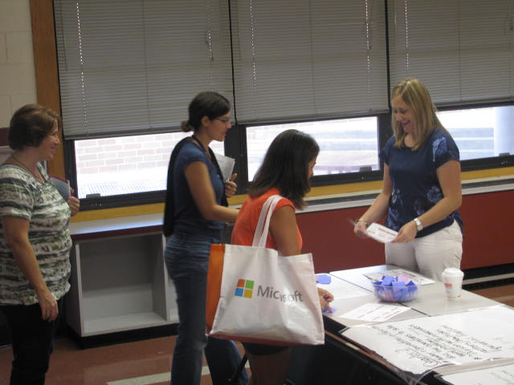

Page 2 of 3

## New Faces

Grade Level News

School Newsletter

**Page 3 of 3**

## Out of Field Teachers

Students who are identified as being displaced/homeless have specific educational rights in the state of Florida. The Okeechobee County School District is happy to share this information with you. If you are interested in learning more, please ask us for a Homeless Education Brochure. You can also find the information at this website:

http://www.okee.k12.fl.us/gsp/html/homeless_documents.html

## Displaced/Homeless Education

Teachers who teach in an area they are not certified in are considered out of field teachers. By law, we must notify parents when teachers are teaching out of field. Leigh Anne Shockley is working on her elementary/ESOL certification. Heidi Moore is working on her ESE certification and ESOL certification. Shana Schneider is working on her ESOL certification. Allison Royal is working on her ESOL certification. Nicole Fenner is working on her ESOL certification. Kara Lydic is working on her ESOL certification. Angela Maxwell is working on her ESOL certification. Please call Mr. Koff at 462-5116 if you have any questions

***Non Discrimination Notice***

The School District of Okeechobee County has adopted Board Policy 6.43, Unlawful Discrimination Prohibited. No person shall, on the basis of race, color, religion, gender, age, national or ethnic origin, genetic information, political beliefs, marital status, sexual orientation, disability, if otherwise qualified, social and family background or on the basis of the use of a language other than English by Limited English Proficiency (LEP) students, be excluded from participation in, be denied the benefits of, or be subjected to discrimination under any education program or activity, or in any employment conditions or practices conducted by this School District, except as provided by law.

The School Board shall comply with all federal and state laws which include the Title II of the Americans with Disabilities Act of 1990 (ADA), as amended by the ADA Amendments Act of 2008 (ADAAA), Title IX, Section 504, Florida Education Equity Act, Age Discrimination in Employment Act (ADEA), Genetic Information Non-Discrimination Act of 2008 (GINA), and the Boy Scouts of America Equal Access Act.

Any employee, student, applicant for admissions, or applicant for employment who believes he/she has been discriminated against or has been harassed by another employee, student, or third party is encouraged to use the Equity Plan Grievance Procedure for filing complaints. You may file with: principal or immediate supervisor, District Equity Coordinator/Director of Human Resources or the Superintendent.

Director of Human Resources

Title II, Title IX and the Florida Education Equity Act Complaints and

ADA/Section 504 Complaints

700 SW 2nd Avenue, Okeechobee, FL 34974

(863) 462-5000 Ext. 267

**Grade Level News**

School Newsletter