Your Letterhead

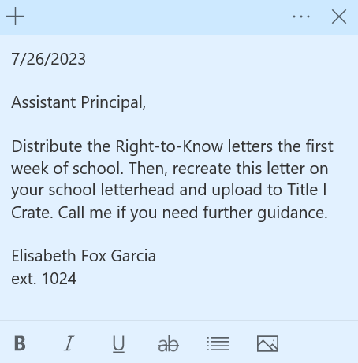

(Insert date)

I, insert name, Assistant Principal at insert school affirm that on insert date the Right to Know letter was given to all students to take home to their parents.
Additionally, the Right to Know letter was posted on the school website on insert date.

Signature
Name, Title

Attachments: Copy of Letters
Screenshot of Website

